NISGTC Lab 16: Forensic Case Capstone Challenge 1

Alex Arnold

Summary of Case:

Susie Stapleton has gone missing for 3 days. Her husband and kids are worried sick. A police officer has acquired an image of her hard drive. The forensic expert is requested to search the drive and document and photos within her profile that could indicate where she is. All relevant photos should be bookmarked and screenshots should added to the report.

Tools:

The tool for this case will be Autopsy version 3.0.8. no imaging software is needed as the image of the drive has been provided by the police for this investigation. This has all been processed on a VM machine specifically set up for this task to prevent contamination of the information due to previous configuration or usage of the VM.

Methods:

I started my investigation by looking at the recent files to determine what the latest file date was as the current date was not stated. This turned out to be 01-08-24. This allows me to search for things like emails or files created in the last 3 days. After this I looked for the users account folders and proceed to search for photos within the users photos folder first. After searching for any mentions of Vegas and looking for any related documents only the pictures were found. Key word searches for user name as well as the word Vegas were used. Deleted files were searched with no results relevant to the investigation. A search of email addresses provided no relevant information for the investigation. The same goes for documents or any other files. The only files of note on the system were the photos. There were also a second copy of the image files located in a VMware folder located on the system. These photos were identical to the other photos on the system.

Findings:

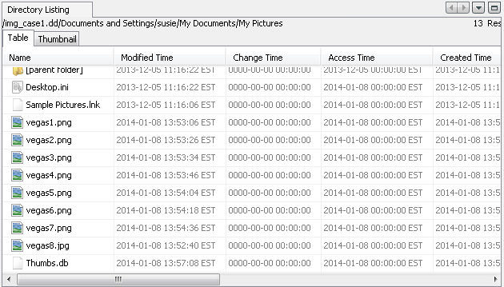

Susie’s account photo folder all images created on 01-08-24. File names were all Vegas followed by a number (vegas1, vegas2, and so on). All photos are of the Las Vegas Strip hotels from the street or an aerial perspective. (Photos below) no other photos or other relevant files were found on the device that are related to the Las Vegas content or any other potential location.

Vegas 1

vegas2

Vegas3

Vegas4

Vegas5

Vegas6

Vegas7

Vegas8

Conclusions:

As the only files and photos on the machine relevant to the investigation that could be found were Las Vegas this is currently the only lead that was to be gathered as to the potential location of the individual in question. With the lack of other photos, emails, documents, and so on that could point in any other direction the only conclusion that I could make is that the investigation should look into Las Vegas as the potential location that Susie Stapelton has gone. The hotel that is most prominently shown in the photos would be the Bellagio Hottel on the Las Vegas strip. Especially in the last photo of the hotel alone as the focus of the image.